Assignment 7PAM2000 Applied Data Science 1
Clustering using Indicator values of different countries
Introduction: Two indicators form the world bank data were used to display three different forms of clustering. The Co2 emission and GDP per sector from the year 1970 till 2018.
figure 1 : This scatter plot displays the CO2 emission and GDP per sector between the year 1970 and 2010. figure 2 : This scatter plot displays the CO2 emission and GDP per sector between the year 1975 and 2018. figure 3: This scatter plot displays the CO2 emission and GDP per sector between the year 1970 and 2000
For Modelling: Data set Housing was used to fit and model. Diagram 4 The model performance for training set -RMSE is 0.2566506099419621, R2 score is 0.7295996076207669. The model performance for testing set-RMSE is 0.3349516693224564 and R2 score Is 0.5394391593518055
  - Figure 4: This diagram displays the heatmap of the data set that was used for the model. From the diagram, correlation coefficient ranges from -1 to 1. if value is close to 1 , it denotes there is a strong positive correlation between the two variables. To fit a linear regression model, features which have high correlation are selected with the target variables from the heatmap, “rm” has a strong positive correlation with mdev(0.7) where “lsat" has a high negative correlation with “medev”(-0.74)

Figure 1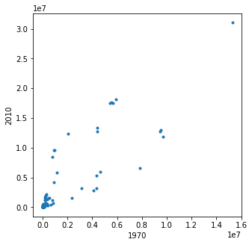 | 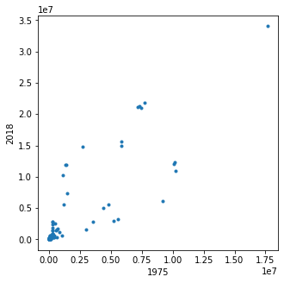  Figure 2
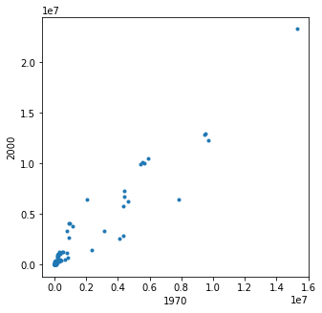Figure 3 | 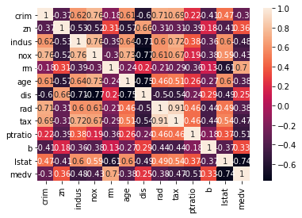  Figure 4

